

**COME AND GO**

**WEDNESDAY, JUNE 14TH, 2023**

**CANAD INNS HSC – AMBASSADOR A ROOM**

**0630 - 2200**



DROP BY FOR A COFFEE, TEA, WATER

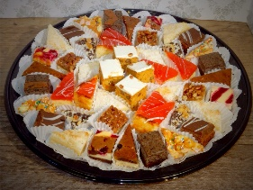

ASSORTED DAINTIES AND DANISHES

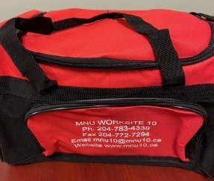

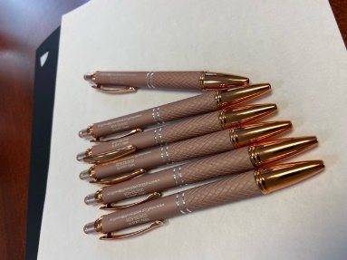 LUNCH KITS PENS



LAWN SIGNS